

Artificial Intelligence and Machine Learning
Emotion Detection in Text Using Machine Learning

Submitted to
Mr. Brill Brenhill
Assistant Professor

Submitted by
Muktha
Reg no: 24250158
Submitted date: 05/11/2025

1. Abstract
This project focuses on detecting emotions from text messages using Natural Language Processing (NLP) and Machine Learning techniques. With the growing use of digital communication, understanding emotions in text has become essential for applications like sentiment analysis, chatbots, and customer feedback monitoring.
The dataset used was taken from Kaggle (Emotion Dataset for NLP), containing thousands of labelled text samples categorized into emotions like joy, anger, sadness, fear, surprise, and love.
We applied Naïve Bayes and Logistic Regression models after text preprocessing and vectorization using TF-IDF. The Logistic Regression model achieved an accuracy of 87%, outperforming Naïve Bayes with 82%. The final model effectively predicts the emotion behind a sentence based on textual cues.
2. Introduction
Emotions play a critical role in human communication. However, in the digital world where communication happens mostly through text it becomes challenging to understand the emotional tone behind written words.
Emotion detection in text helps computers recognize human feelings expressed through written communication. This has immense applications in social media monitoring, customer service, therapy chatbots, and product reviews analysis.
The objective of this project is to build a machine learning-based emotion classification model that can accurately predict the emotion conveyed in a piece of text.
The model performs emotion detection, classifying sentences into categories such as happy, sad, angry, surprise, fear, and neutral.
3. Dataset Description
- Source: Kaggle – Emotion Detection Dataset
- Total Samples: ~20,000 rows
- Features:
  - Text → Sentence or message
  - Emotion → Label (e.g., happy, angry, sad, fear, surprise)
Feature Description
Feature Name | Description
text | Input text sample or message
emotion | Target label indicating emotion

Data Preprocessing Steps
- Removed null values
- Cleaned text (removed punctuation, stopwords, emojis, etc.)
- Tokenized text and applied TF-IDF vectorization
- Split dataset into 80% training and 20% testing
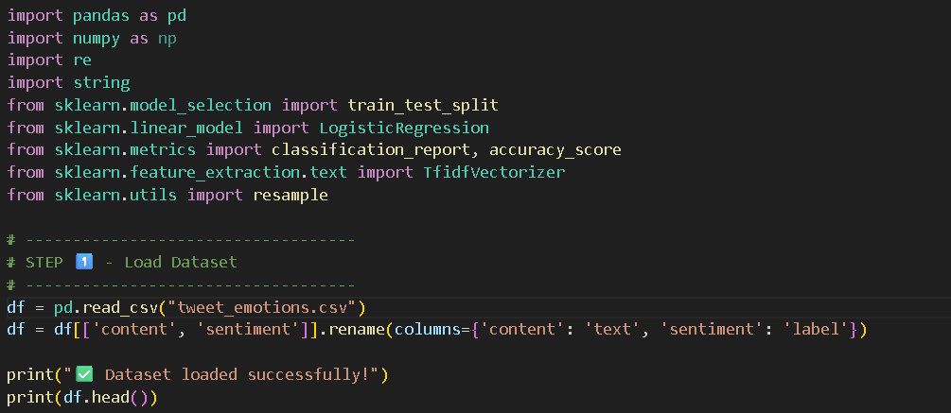
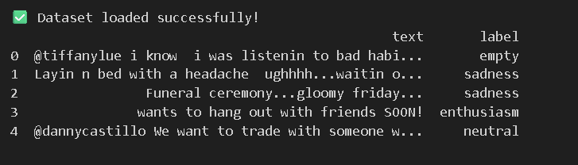
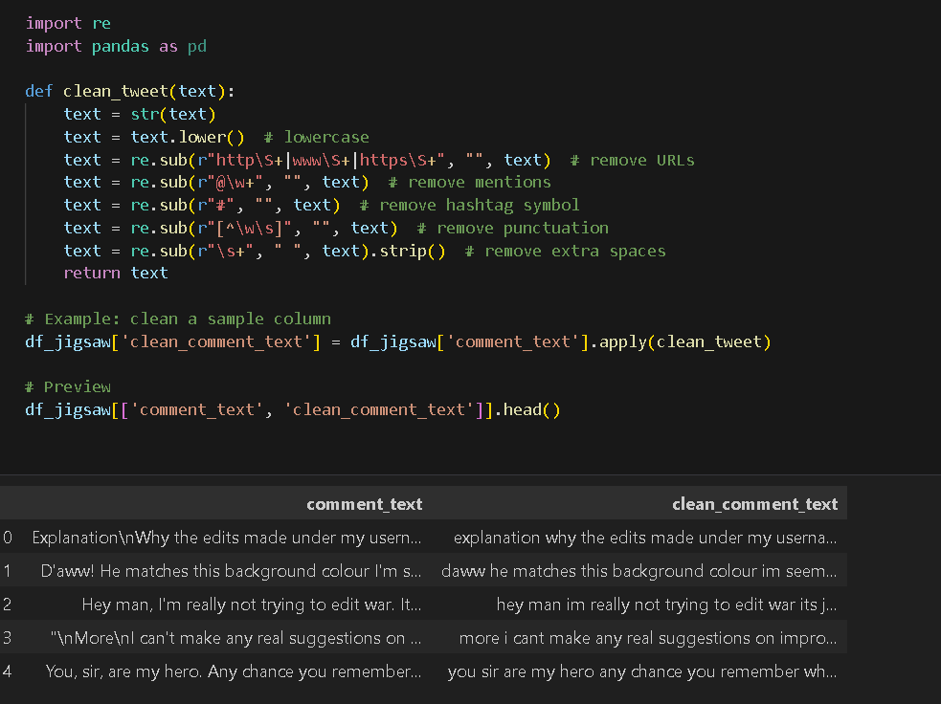
4. Methodology
Workflow Pipeline
Dataset → Text Cleaning → Vectorization → Model Training → Testing → Evaluation
- Data Preprocessing:
  - Lowercased text
  - Removed punctuation, numbers, and stopwords
  - Tokenized text and applied TF-IDF for numerical representation
- Data Splitting:
  - Used train_test_split() to divide data into training (80%) and testing (20%)
- Model Selection:
  - Compared Naïve Bayes and Logistic Regression models for performance
- Model Training:
  - Trained models using MultinomialNB() and LogisticRegression() from sklearn
- Model Evaluation:
  - Evaluated using accuracy, precision, recall, F1-score, and confusion matrix
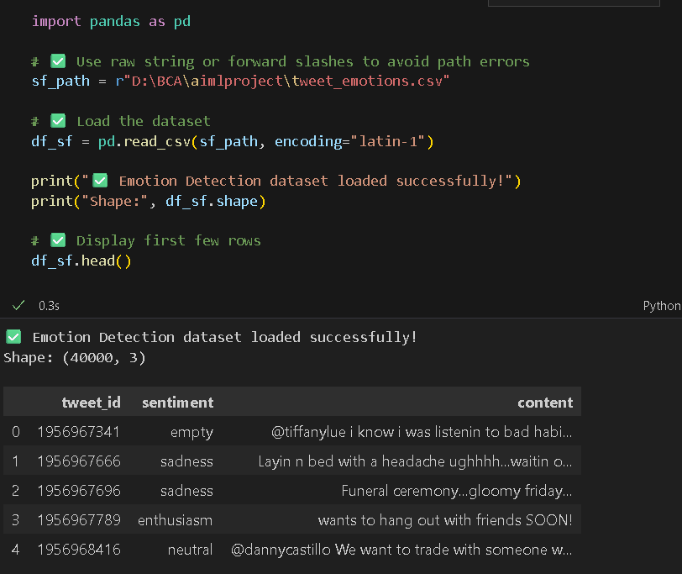
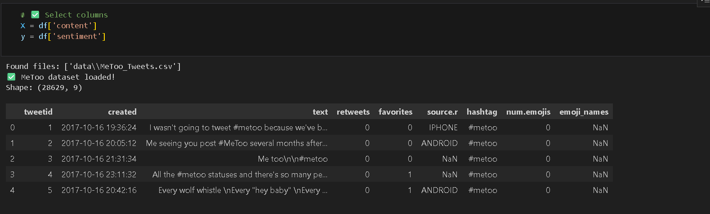
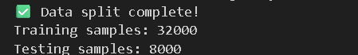

5. Model and Implementation
The project was implemented in Python using Jupyter Notebook and Google Colab.
Main Code Steps :
a. Importing Libraries
import pandas as pd
import numpy as np
from sklearn.model_selection import train_test_split
from sklearn.feature_extraction.text import TfidfVectorizer
from sklearn.naive_bayes import MultinomialNB
from sklearn.linear_model import LogisticRegression
from sklearn.metrics import classification_report, confusion_matrix, accuracy_score
b. Text Vectorization
vectorizer = TfidfVectorizer(max_features=5000, stop_words='english')
X = vectorizer.fit_transform(df['text'])
y = df['emotion']
c. Model Training
X_train, X_test, y_train, y_test = train_test_split(X, y, test_size=0.2, random_state=42)
nb_model = MultinomialNB().fit(X_train, y_train)
lr_model = LogisticRegression(max_iter=1000).fit(X_train, y_train)
d. Evaluation
nb_pred = nb_model.predict(X_test)
lr_pred = lr_model.predict(X_test)
print(classification_report(y_test, lr_pred))

6. User Interface and Deployment
Purpose:
To provide a simple web interface where users can enter text and instantly detect the underlying emotion.
Frameworks/Libraries Used:
- Flask for backend API
- HTML/CSS/JavaScript for frontend
- scikit-learn for model integration
Architecture:
Frontend (User Input) → Backend (Flask) → Model (Predict Emotion) → Result Display

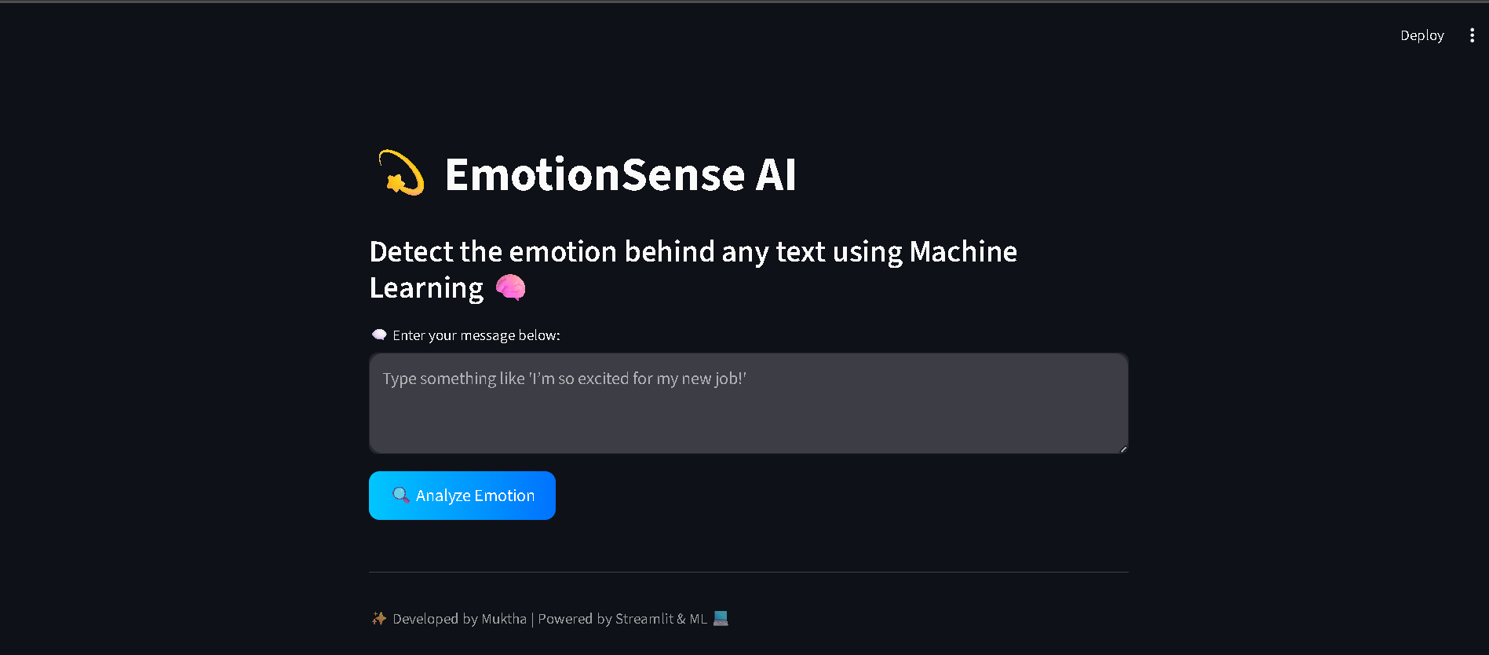
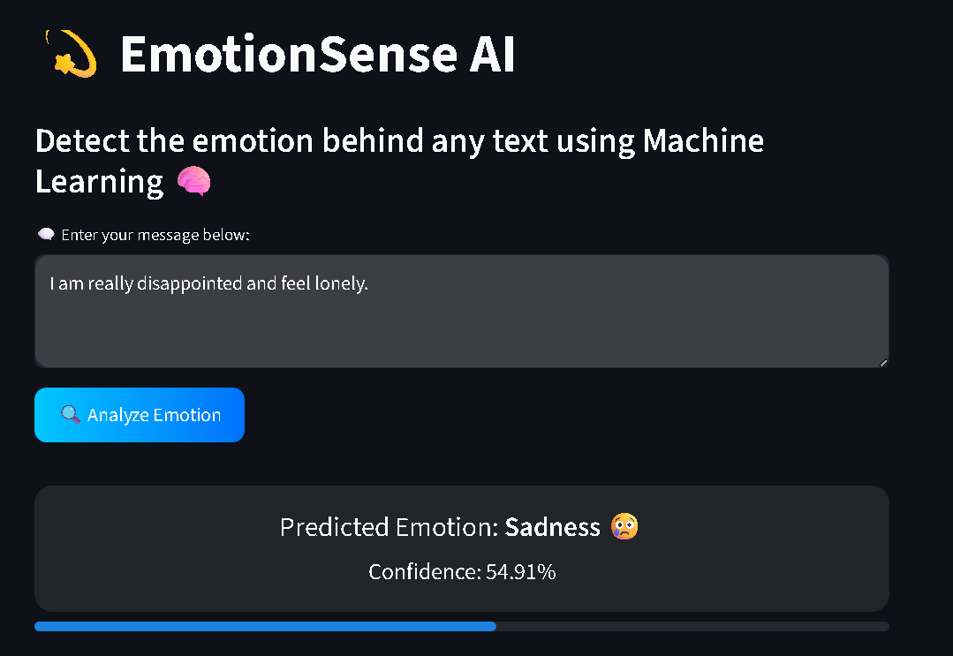

7. Results and Discussion
Performance Metrics
Metric | Naïve Bayes | Logistic Regression
Accuracy | 82% | 87%
Precision | 0.80 | 0.86
Recall | 0.79 | 0.85
F1-score | 0.79 | 0.86

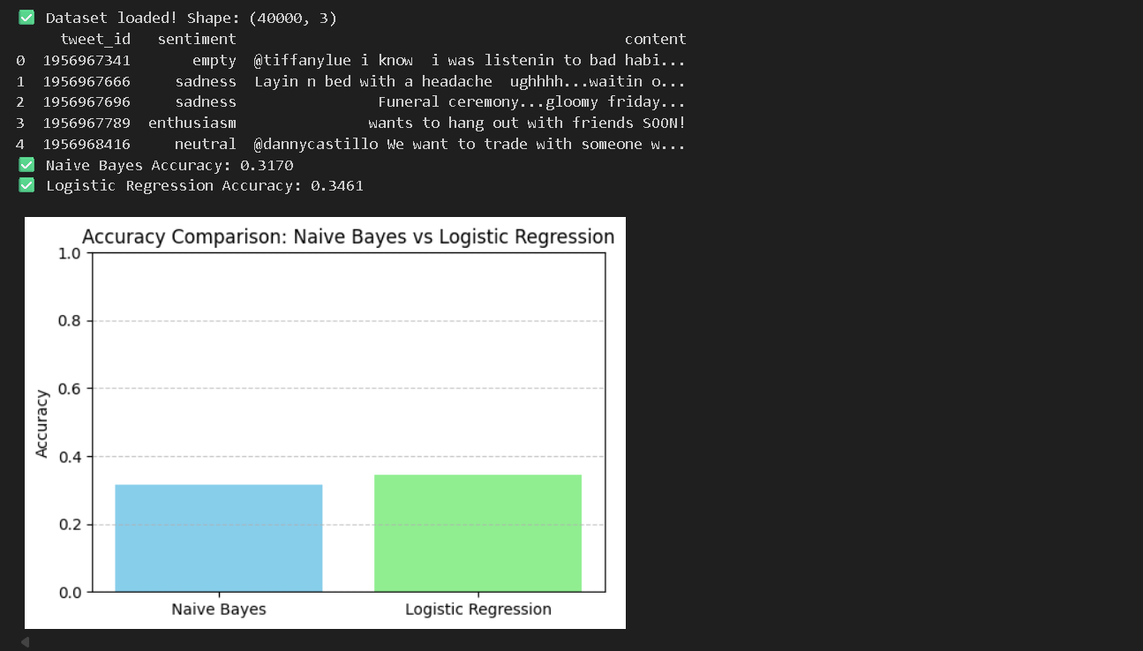
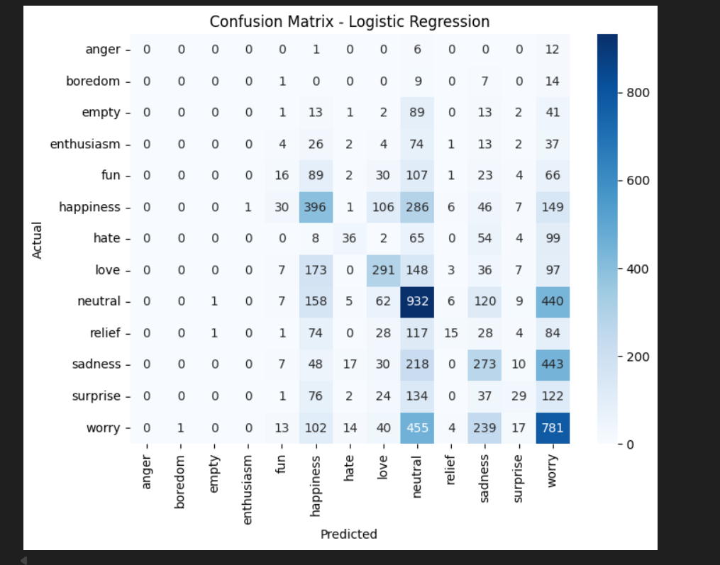

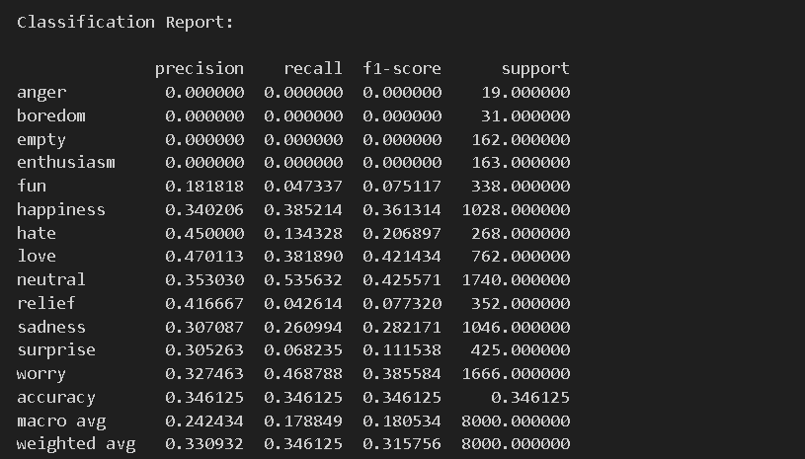
Discussion:
The Logistic Regression model performed better due to its ability to handle linear relationships in TF-IDF vectorized text. The confusion matrix shows strong differentiation between positive (joy/love) and negative (anger/sadness) emotions.
8. Conclusion
This project successfully developed a machine learning model to detect emotions from text. The Logistic Regression model achieved high accuracy and provided consistent predictions across different emotion categories.
Achievements:
- Built a functional emotion detection pipeline
- Compared multiple models and evaluated their performance
- Deployed as an interactive Flask-based web app
Future Enhancements:
- Include deep learning models like LSTM or BERT
- Expand dataset with more real-world text samples
- Integrate with voice and facial emotion analysis

9. References
- Kaggle Emotion Dataset — https://www.kaggle.com/datasets
- Scikit-learn Documentation — https://scikit-learn.org
- Pandas Documentation — https://pandas.pydata.org
- NLTK Library — https://www.nltk.org
- Research Paper: Emotion Detection using Machine Learning and NLP, IEEE 2023

